**April 8, 2024**

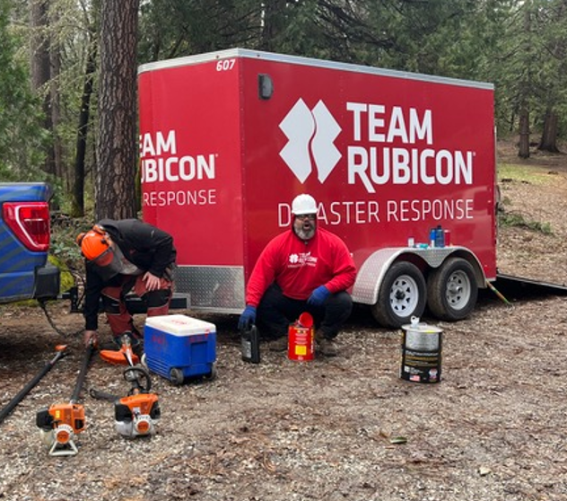

**Camp Fire Teams up with Team Rubicon**

**for a Weekend of Forest Management at Camp Gold Hollow**

We’ve all become more wildfire-conscious in recent years – Camp Fire included! Our beautiful Camp Gold Hollow sits in a mature forest of pine, incense cedar, madrone and oak.

Winter snow and rain, and the warmth of spring, always bring new forest growth. The trees, shrubs, small plants and grasses absorb carbon dioxide – CO2 – from the atmosphere. They give us back the oxygen to breathe, and they use the carbon to build new leaves, branches, stems and needles. This material becomes part of the forest.

The small trees and bushes that grow under the tall pines are called the “understory.” When the understory grows dense and brushy, it provides what foresters and firefighters call “ladder fuels.” If a fire starts on the ground, the flames use the brush and branches as a “ladder” to climb up into the tall trees, causing a fire in the forest crown. The fire can then spread quickly across the landscape.

Good forest management involves reducing thick brush and low branches so the fire can’t spread as fast, and firefighters can put it out more quickly. When native people lived on this land, they often used smaller fires to keep the forest healthy.  But this had not happened near Camp Gold Hollow for more than 100 years. Camp Gold Hollow’s underbrush was in desperate need of a “haircut.”

Thinning the forest understory is hard work. It requires chain saws, pole saws, weed whackers, loppers, rakes, chippers, safety equipment like gloves, helmets and eye protection, and lots of muscle. [Team Rubicon](https://teamrubiconusa.org/), a non-profit organization that helps people before, during and after natural disasters, came to our aid.

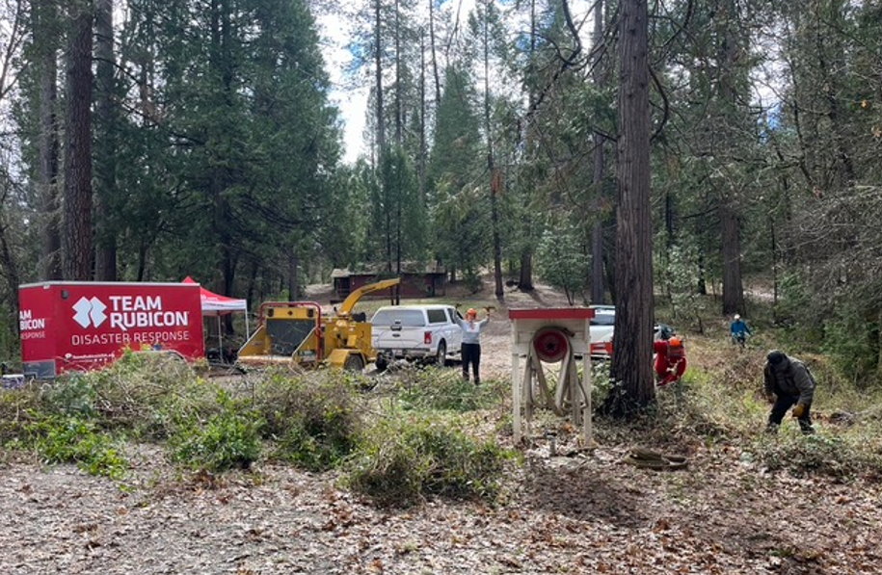

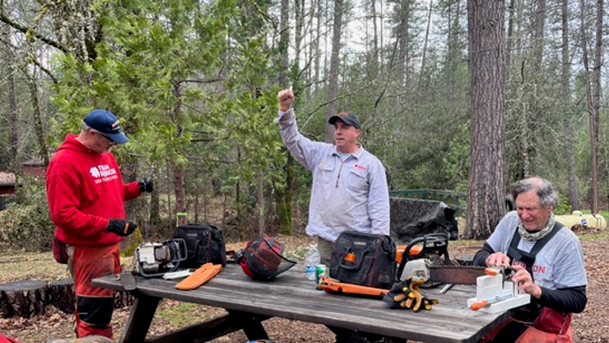

The weekend of March 23-24, despite a rainy weather forecast, twelve volunteers from Team Rubicon brought a trailer-full of chain saws and other equipment to Camp Gold Hollow and spent two full days clearing underbrush, cutting branches, removing dead trees and running the trimmed material through a wood chipper. They spread the resulting wood chips on the forest floor, where they will decompose and turn into mulch that will add nutrients to the soil and reduce erosion.

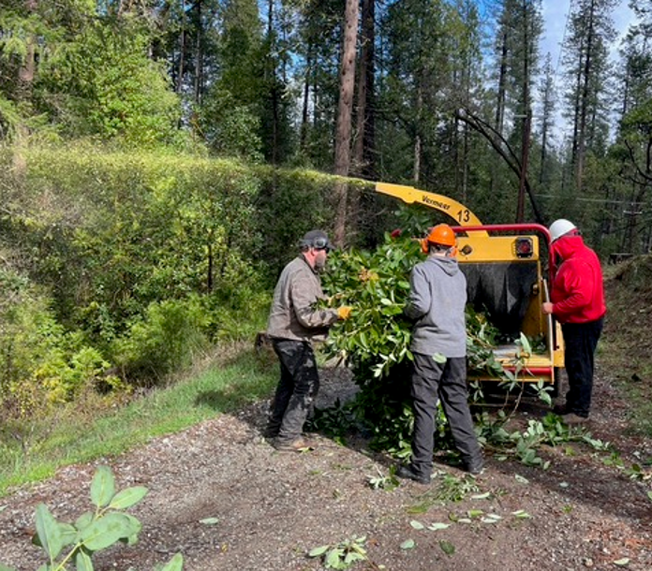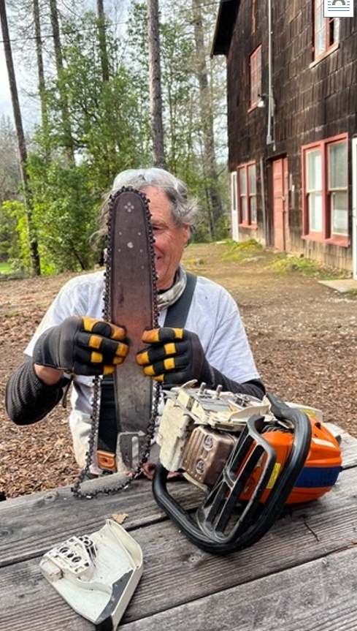

Camp Caretaker Bob DeHart, who organized and oversaw the work, was impressed with the results. “These guys did a great job. We’d love to have them back again.”

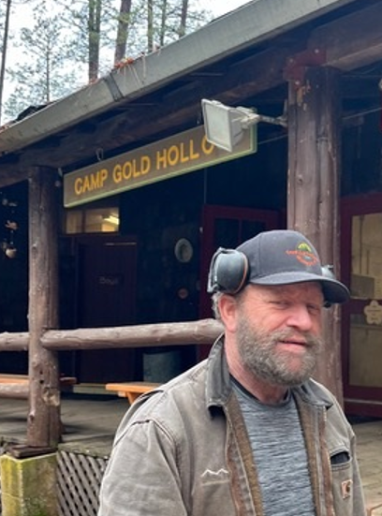

**Caretaker Bob DeHart**

Team Rubicon was backed up by a support team of Camp Fire volunteers. Camp Director Patty McCulley, her husband Shawn, and board member Gemma Miner made meals and washed dishes for the crew.

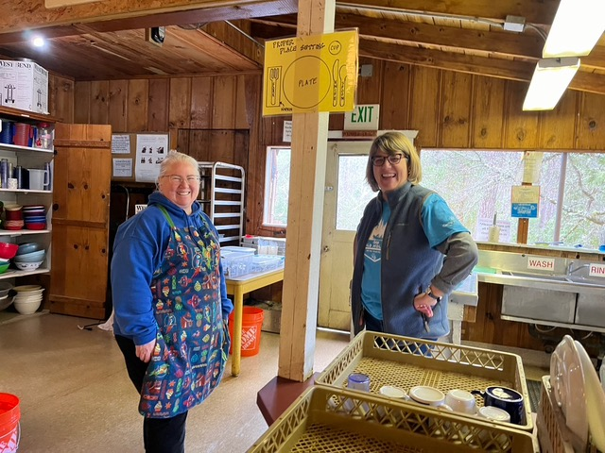 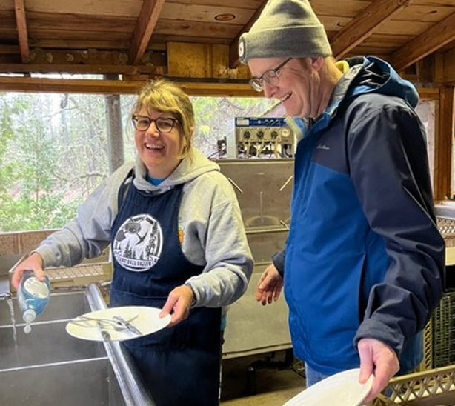

**Board Member Gemma Miner, Camp Director Patty McCulley and husband Shawn McCulley**

Thomas Sutfin Kerr, a registered professional forester, and his wife Ann Baier celebrated their wedding anniversary by coming up to camp to help out. Says Ann: “It was inspiring to work with Team Rubicon. I was impressed with their respect for each other as people and willingness to give their energy and excellent skills. They had an outstanding emphasis on safety, with consistent procedures for good working relationships (for example, saying ‘chain saw starting’ each time before they did), caring for the team physically by taking rest breaks and by staying hydrated and fueled up. They also looked out for each other emotionally, recognizing that many people have suffered trauma in their lives, and need to be treated kindly. They showed great respect for each other as people. The evening provided time to spend together, talking about the day or their lives, sharing stories or joking around. They expressed great appreciation for us and for our facility.”

Brandon Torigian, Team Rubicon’s Northern California Operations Associate, said: “We are equally grateful for the opportunity to have worked with your fantastic Camp Fire team. Working alongside Bob, Thomas, Ann, and the entire cooking crew was an absolute pleasure, and we're thrilled to hear that you enjoyed the experience as much as we did.”

Both Team Rubicon and the Camp Fire crew hope to get together in the fall for more fire prevention work at Camp Gold Hollow.